* 1. *Count total no. of employees.*

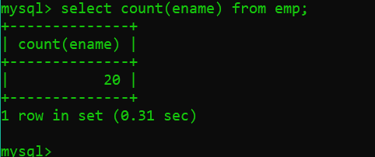

* 1. *Determine the maximum and minimum salary.*

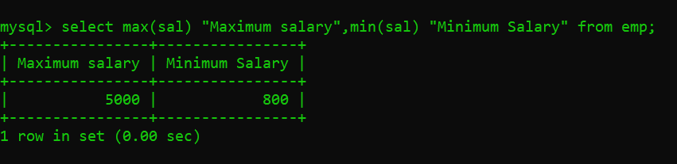

* 1. *Display the count of employees having salary greater than 3000.*

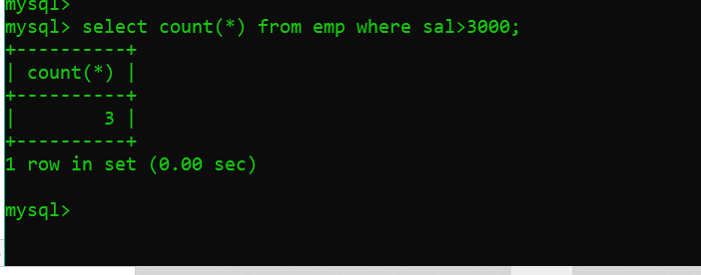

* 1. *Print department wise count of employees*

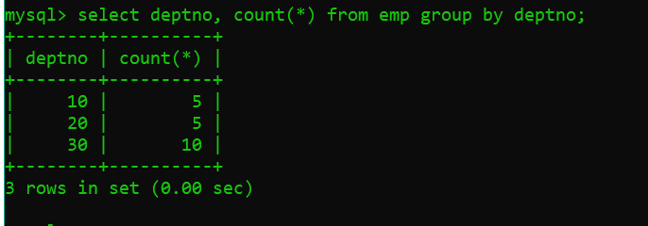

* 1. *Display employee details who earn maximum and minimum salary.*

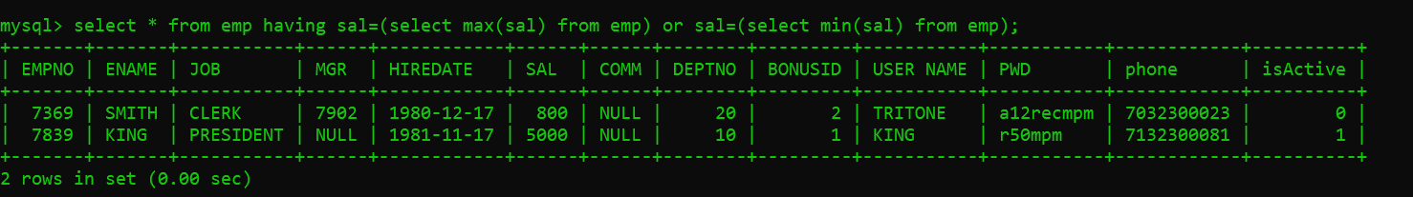

* 1. *Print jobwise total salary.*

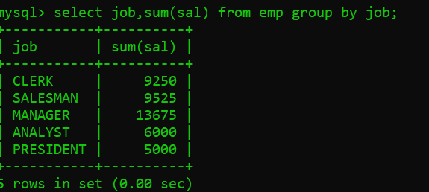

* 1. *Print department wise maximum salary.*

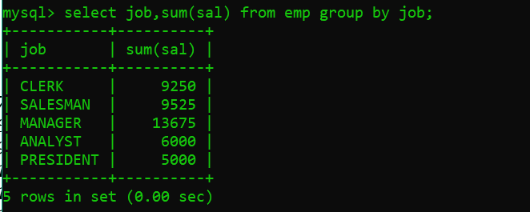

* 1. *Print jobwise average salary.*

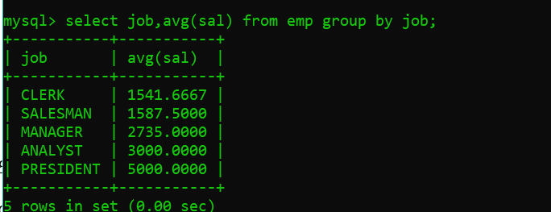

* 1. *Print count of employee working in department 20.*

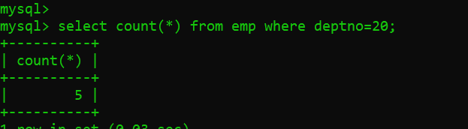

* 1. *Print count of employee working in department 10 having job as MANAGER..*

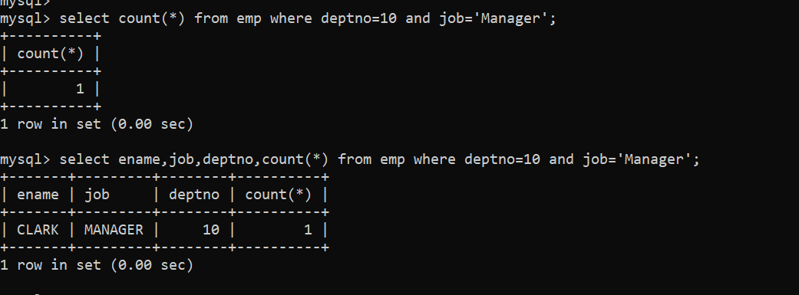

* 1. *Print count of employee working in department 20 having comm as null.*

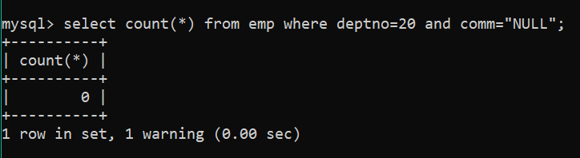

* 1. *Print names of employees working in ACCOUNTS department having maximum salary.*
  2. *Print employee details having salary less than average salary of MANAGER.*

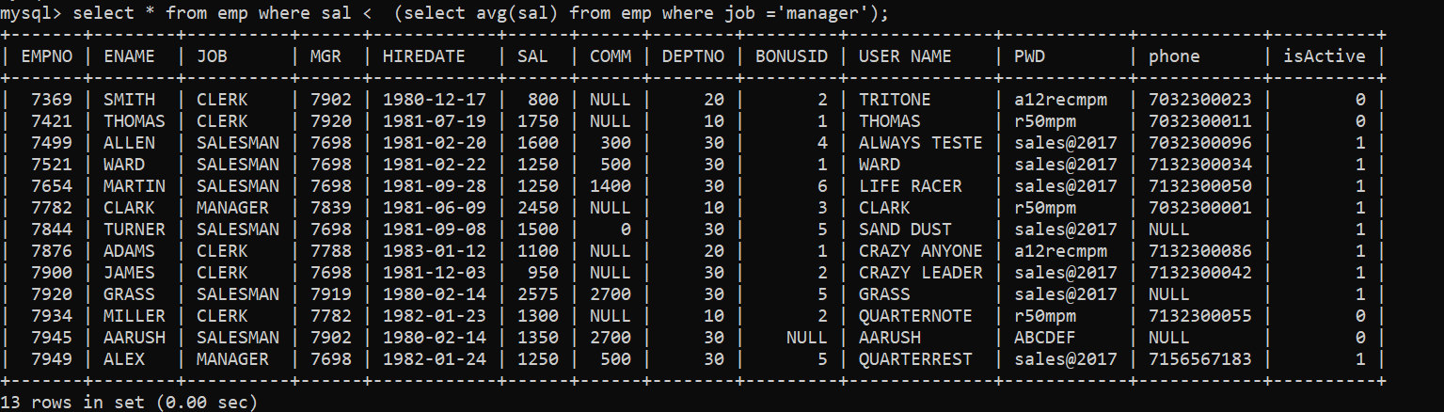

* 1. *Give SQL statement to find the average annual salary per job in each detp.*

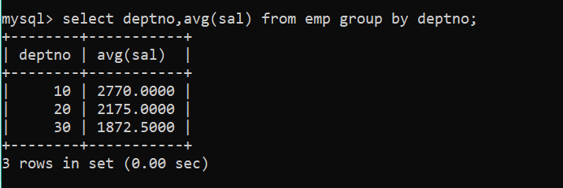

* 1. *Count the number of people in the dept 30 who receive a salary and the no.of people who receive comm.*
  2. *Calculate the avg, min and max salary of those groups of employees having the job as CLERK or MANAGER.*
  3. *Display the deptno of departments which have more than one CLERK.*

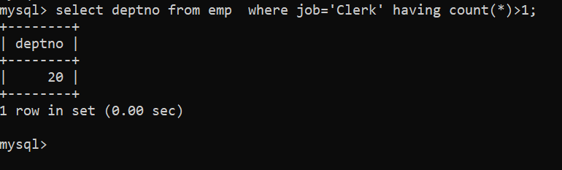

* 1. *List names and hiredates of employees who were hired in the month of December*
  2. *List names and hiredate of employees hired in the year 1980*

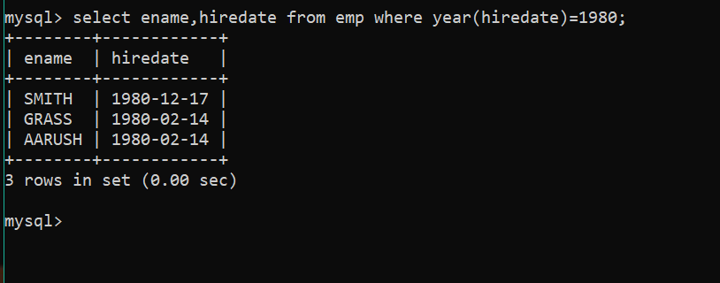

* 1. *Display names and jobs of the people separated by a hyphen. Capitalize the first character of name and job.*

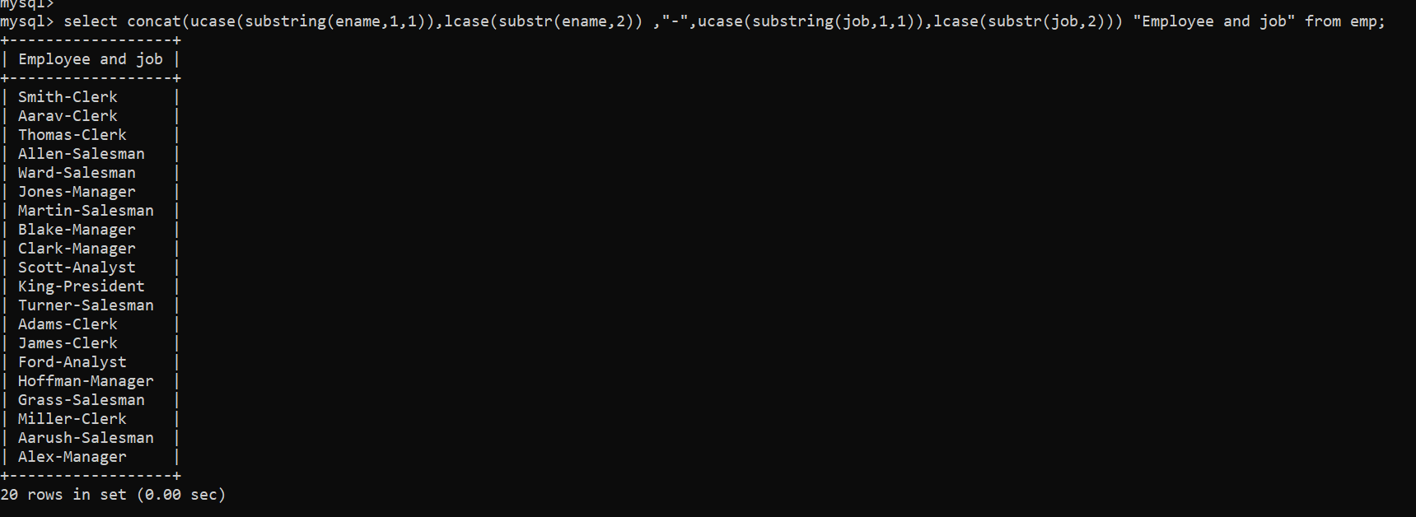

* 1. *List employee numbers, names and hiredates of the people working in the department number 20, display the hiredates in the dd/mm/yy format*
  2. *Find number of months the president has worked for the company.*
  3. *Find the day of the week on which SMITH joined*
  4. *Find the time of time of the day in which ADAMS joined*
  5. *Find day of month on which KING joined*
  6. *Find out month on which MARTIN joined*
  7. *Find out which quarter of the year the employees joined. Display their number and names as well*
  8. *Retrieve ANALYST records with the hiredate formatted as – ‘The 3rd of December 1984’*
  9. *List all names, jobs, and a job classification number, which is to be assigned by you. Translate the value started in each job field to a job classification number. This is to be done as follows-*

1. *CLERK*
2. *MANAGER*
3. *PRESIDENT*
4. *OTHER*
   1. *Display the length of the longest employees name*
   2. *Write a query to list the length of service of the employees (of the form n years and m months).*
   3. *How many employees who are joined in 1985.*
   4. *How many employees joined each month in 1985.*
   5. *How many employees who are joined in March 1985.*
   6. *Find the total sales amount*
   7. *Find the customer-wise lowest and highest sales amount*
   8. *Find product-wise lowest, highest and total sales.*
   9. *Find department-wise average salary for all the departments employing more than three employees*
   10. *Find the customer-wise total sales for all the customers except ‘TKB SPORT SHOP’ who came to purchase various sports items maximum four times.*
   11. *Display the highest, lowest, sum and average salary for all employees. Label the columns appropriately.*
   12. *Modify the above query and display the output for each job type.*
   13. *List names of people who have salary less than the average salary for dept 20*
   14. *Find the average annual salary per job in each department.*
   15. *Count the number of people in department 30 who receive a salary and the number of people who receive a commission*
   16. *Compute the average, minimum and maximum salaries of these groups of employees having job as Clerk or manager, Display the job as well*
   17. *Write an SQL command that displays 2nd highest salary paid*
   18. *Write a query to find the employees who are earning the maximum salary in their departments.*
   19. *Write a query to find the salesman number (repid) who has achieved the maximum total sales among the entire salesman.*
   20. *List the highest salary paid for each job.*
   21. *Find the most recently hired employee in each department.*
   22. *In which year did most people join the company? Display the year and the number of employees.*
   23. *Write a query to display employee name whose name occurs only once in the table.*
   24. *Write a query to display all the details from dept table along with the no. of employee working in each dept.*
   25. *Find out which department does not have any employees.*
   26. *List out the no. of employees joined in every month in ascending order.*